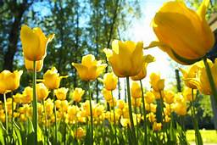 Spring Menu…Week 1

 | Monday | Tuesday | Wednesday | Thursday | Friday
Breakfast | Cereal  Fruit  Toast  Milk | Scrambled Eggs with Cheese  Toast  Fruit  Milk | Blueberry Muffins  Yogurt  Milk | Banana Waffles  Yogurt  Milk | Egg and Turkey Sausage Scramble  Toast  Milk
Morning Snack | Cheese Nachos  Water | Graham Crackers  Cream Cheese  Water | Carrots  Ranch Dressing  Crackers  Water | Applesauce  Crackers  Water | Cinnamon Apples  Vanilla Wafers  Water
Lunch | Chili Mac  Cornbread  Veggies  Milk | Chicken Salad Sandwiches  Roasted Potatoes  Ketchup  Milk | English Muffin Pizzas  Oranges  Milk | Pasta Salad with Veggies  Cheesy Bread  Milk | Dirty Rice  Veggies  Bread  Milk
Afternoon Snack | Fruit and  Grahams  Water | Popcorn  Raisins  Water | Snack Mix  Water | Meat  Cheese  Water | Cheese  Crackers  Water

